# **Practical – 3**

**AIM: Draw E-R diagram and class diagram for chosen application**

* 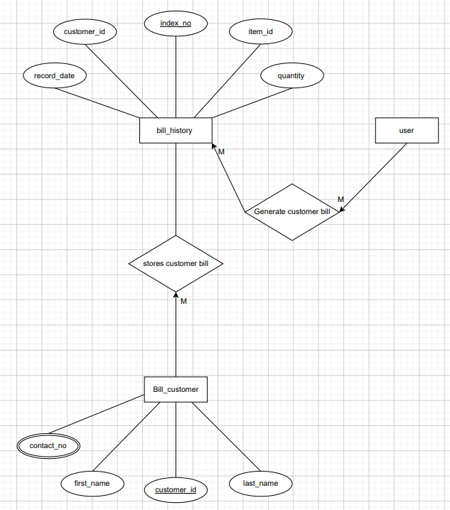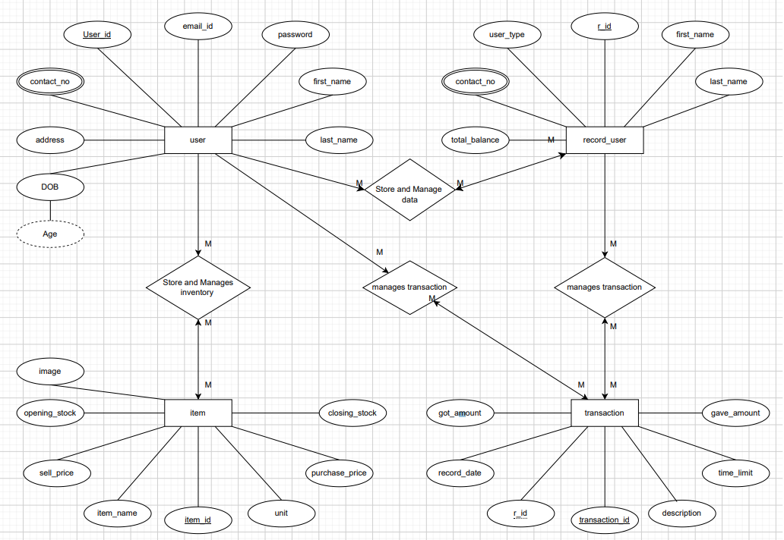**ER – Diagram**
* **Class Diagram**

